Post Independent / Citizen Telegram / Free Press
Serving Glenwood Springs, Rifle, and Grand Junction, CO
July 21, 2012

John Colson
jcolson@postindependent.com

MARBLE/marble Symposium draws dozens of sculptors
| 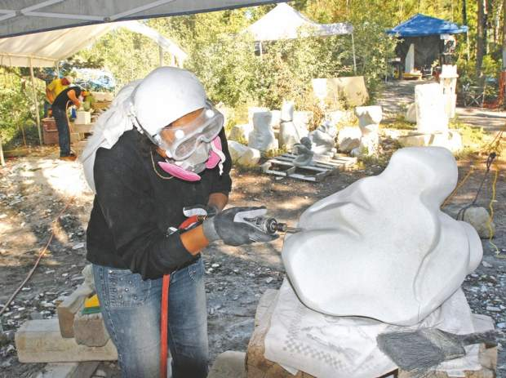
Kelley Cox, Post Independent. Sculptor Fortuna Szpiro has come from Israel for the second time to attend the MARBLE/marble stone carving symposium in Marble. The month-long annual event attracts artists from across the country and around the world.
MARBLE, Colorado - Now in its 24th year, the MARBLE/marble Symposium has grown up, according to its founder and director, Madeline Wiener, herself a noted sculptor.
MARBLE/marble offers three weeklong sessions in July for sculptors, from beginners to professionals, to live and work in Marble. A team of four instructors and five staffers assist about three dozen students per session, and many students enroll for two or all three sessions.
"We're here to stay," said Wiener.
The symposium is the main project of the Marble Institute of Colorado, a nonprofit that fosters training and development for stone carvers.
The action takes place on not quite five acres of land that once was part of the massive Colorado Yule Quarry mill site. In 1996, the Stover family donated the property to the Institute.
Annexed and put on the town's water system, the town government has also approved improvements to the internal dirt roads and campsites on the property. The campus boasts a new set of toilets and showers, built in 2011 of discarded marble rounds. And the kitchen area, where meals are prepared for staff and students, has been improved.
"The town of Marble has been very generous about putting up with us over the years," Wiener said. Residents open their homes to participants who prefer not to camp out at the symposium site.
Following a brief slump in participation that Wiener attributed partly to the recession, the symposium has seen its numbers rebound in 2012, said Wiener.
"We've had as many as 64 carvers here," said Wiener, "but that was too many for the staff to handle. We prefer 45. It's a good break-even point."
The symposium attracts sculptors of all levels from all over the world, including Israel, Switzerland, Australia, Austria, the British Isles, Mexico and Japan.
Wiener said she was teaching in India and met sculptors there who have subsequently come to teach at the symposium.
One of those, Ravinder Bhardway, has been teaching at the symposium for nine years, she said. He is nicknamed "the walker" because every day he walks up to the ghost town of Crystal and back to the symposium site.
Wiener, aside from her devotion to the symposium, is a well-known sculptor around Colorado. She currently is working on a set of massive pillars for the new state justice center in Denver.
Symposium participant Nathan Slape, who began sculpting bronze while a student at Colorado Mesa University in Grand Junction, said he has been coming to the symposium since 2005. He is now Wiener's assistant on her project in Denver.
Slape said he mostly works in surreal and abstract shapes, and switched to stone work at the urging of a friend.
"Every piece is unique," he said of working in marble. "That was a major turn-on for me."
Working in bronze was interesting, but was not as liberating as marble, he said. The stone itself influences the artist's thinking in the way it is veined, or in the character of the grain of a particular block of marble.
Beginning sculptor Victor Luster, a 60-year-old from Santa Clarita, Calif., said he was nudged into attending by his wife, also an artist.
A former Internet technology manager for 3D Software, Luster said he turned to art at the urging of an artist friend, and got hooked.
"It's just a love of sculpting, the three dimensions, I guess," he said of the medium.
Describing the symposium, he said, "I think it's great. I'm in awe, especially of some of the sculptors that are here."
He pointed in particular to three large horse figures by Vicky Branson, wife of a symposium instructor, as an example.

